Regional Championship

Post-mortem

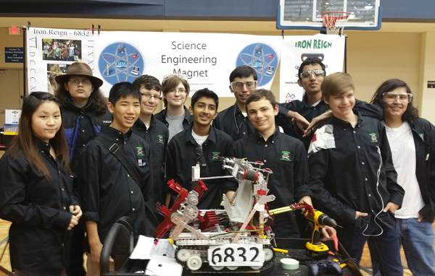
Iron Reign
02.30.2016

READ THIS
AAAARGHH!!!!!!!!!!!!!!!!!!!!!!!!!!!!!!!! Well at least we got to the Semi Finals. Proof:
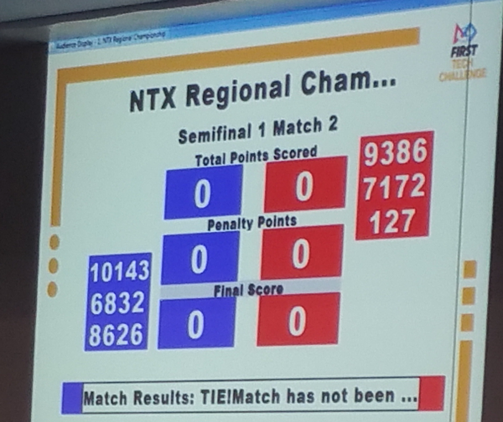

PROCEDURE
- Read the entire document
- Add notes or add rows when you see anything missing from the review
- Add your initials in the VOTE column if you want to be part of the solution to the particular problem
- Sign-in at the bottom to show that you at least read the document

ROBOT - Chassis
ISSUE | SUGGESTIONS / ALTERNATIVES | VOTE
Didn’t throw a track this time, but it remains a risk | - Experiment with alternate tread materials for longer-term | Dylan  Max
Plow failed constantly | - Add taller aluminum plate to steel rod so balls and blocks won’t hop over the plow  - Bolt came off - need longer bolts or a better way to attach to hinges | Ethan  Evan  Max
Balls get caught underneath when plow is up and debris is being spilled | - Add a thin plate below the CliffHanger that stops balls from getting under the robot when plow is up. | Omar

ROBOT - CliffHanger
ISSUE | SUGGESTION | VOTE
Cliffhanger motors can fight each other - if they develop slightly different ideas about current position - then they get really hot | - Software monitor to see if extension motors are busy when they should not be moving. Also check to see if their current position reads differently for longer than a second. | Omar  Tycho
Cliffhanger calibration doesn’t work if we bypass autonomous | - Fix | Tycho
Need presets for Extension / Retraction | - Tape ticks-per-meter already worked out.  - Measure common extensions for Mountain and Cliff targets  - Figure out which Mountain mode control buttons to use  - Continue manual override for strange situations | Tycho, Omar, Darshan
Need rapid replacement of entire system | - DONE! | Trace

ROBOT - BEATER BAR / DEBRIS COLLECTION
ISSUE | SUGGESTION | VOTE
Bar broke - needs different mounts to motors/sprockets | - Replace with printed design Max made for Imperial last year
No “All Clear Signal” solution. This is the V on top of the mountain. | - Trough, if it rotates more, could serve as a hanging lock and a way to pull down the V (all clear signal)  - Maybe a modification to the plow would work.  - Or a dedicated hook. Probably the best bet.  - Could also modify cliffhanger to hit it | Omar  Ethan
Blocks fall short (side to side) or long (front/back) outside of bins if robot is not positioned correctly. | - Look at pitch from IMU to test forward/backward position.  - Sideways IR sensors to get left/right position on ramp.  - Better visual feedback via LEDs  - side guides | Tycho
Blocks can fall off side of ramp tines. | - Guard tines on either side  - May need overhead rake to guide blocks into trough - prevent overshoot | Max

ROBOT - DRIVER SUPPORT (reduce demands on driver)
ISSUE | SUGGESTION | VOTE
Automatic Mountain Alignment | - Add Sharp IR sensors for wall following  - Use IMU to maintain heading on mountains  - Enable mountain mode automatically based on IMU pitch  - Use huMoments to find lines in OpenCV and determine ramp center from that (long term)
Automatic Mountain Scaling | - Sync cliff-hanger retraction/extension with track motions  - Maintain manual override for abnormal situations | Omar
Direction toggle | - backwards and forwards | Tycho
Drive team | - Make designated robot team, have subs, but one main squad. We tried to have different people but ended up with same team as last competition. If this works keep the team and have them practice together, otherwise make a permanent team with 1-2 subs when a person needs a break.  - more practice | Jayesh, Dylan, Omar

ROBOT - AUTONOMOUS
ISSUE | SUGGESTION | VOTE
We’ve never fully tested it | - Make a schedule for practices with goals for each meeting (include specific number of times to run.) | Lux
Button pushing tails | - Add servo-based brake on tape so it can’t be pushed back into the reel  - Improve PID on color tracker | Max
Doesn’t have alternate modes | - Mode to climb lower mountain  - Alternate starting location
Pre-match option selection needs to be easy and fast | - Driver Practice  - Driver Station Setup Menu

ROBOT - Missing Features
ISSUE | SUGGESTION | VOTE
No solution for triggering mountain climbers | - Bar that extends to either side of the robot at the right height | Max  Ethan
Solution for All Clear signal |  | Omar

PRESENTATION
ISSUE | SUGGESTION | VOTE
Too much dependence on Jayesh and Caitlin | - Move slides to other speakers  - practice q&a where everyone has designated topics to answer over | Everyone
Not very fluid | - practice  - practice  - practice | Everyone
Optimize last half of slide desk | - Give practice demo to non-team=members and ask for feedback. | Jayesh
Integrate live demo | - show the video of the basketball hoop as you are speaking: memorable.  - practice | Ethan Dylan
Forgot to supply Control award sheet | - Control award needs better graphic  - Autonomous program | Dylan

Tournament Prep & Protocols
ISSUE | SUGGESTIONS
Packing out for tournaments disorganized, items forgotten,people stressed | - Generate a reusable checklist & post to blog. Classify categories/storage boxes.  - Designate boxes for specific items/categories and attach labels of contents  - Pack and prepare the night before  - Give each person specific assignments/responsibilities  - Have a master list of all boxes that need to be packed. | Lux Dylan  Caitlin
Last minute journal printing | - Deadline for journal 48 hours before the competition. | Caitlin
Battery maintenance haphazard - we failed hugely on this. We had a brand new battery and failed to use it because nobody put powerpoles on it. And we used batteries marked bad. | - Develop a solid protocol  - Appoint a Charge Czar to be responsible for maintenance of batteries and tracking the battery charging box before and throughout tournament.  - ID all batteries and their health and current rate of charge  - Purchase a bigger power-bank for phone charging. | Caitlin
Develop a memorable brand or “team spirit” concept | - Iron Reign as Roman Legion--develop a standard to carry into competition (probably for team in the stands)  - Update photos/banners to current year. | Darshan  Alisa
BUSINESS SECTION
Develop Sponsors | Sponsor package  Print certif
Sponsor Follow though | Print/send certificates  TWC - special requirements  PTC - apply for grant repurposing
Grant Writing
Budget Development
Planning & Project Management | Seasonal Gantt Chart

Check In
Name | Sections I worked on

